* **MS OFFICE 365 PERSONAL 32-BIT/X64 1 YEAR SUBSCRIPTION**

**Top features**

**1 year subscription includes the latest full Microsoft Office applications**

**Office on 1 PC or Mac, plus 1 Windows tablet or iPad**

**Easily access your docs with Office Mobile apps for iPhones, Android, and Windows phones**

**1TB OneDrive online storage**

|  |  |
| --- | --- |
| **The best Office for you, at home or on the go** | |
| http://www.dabs.com/Images/1/PDM/Office-Sku/compare_word.png | * In the new read mode, text reflows automatically in columns for easier on-screen reading. Fewer menus mean higher focus on your content, accompanied only by tools that add value to your reading. * Open a PDF in Word, and enjoy editing content, such as paragraphs, lists and tables, as if you created it in Word. * Show your style and professionalism with templates, plus save time. Browse Word templates in more than 40 categories. |
| http://www.dabs.com/Images/1/PDM/Office-Sku/compare_excel.png | * In Excel 2013 each workbook has its own window, making it easier to work on two workbooks at once. It also makes life easier when you’re working on two monitors. * You’ll find several new functions in the math and trigonometry, statistical, engineering, date and time, lookup and reference, logical, and text function categories. * The new Recommended Charts button on the Insert tab lets you pick from a variety of charts that are right for your data. Related types of charts like scatter and bubble charts are under one umbrella. |
| http://www.dabs.com/Images/1/PDM/Office-Sku/compare_onenote.png | * Smoothly draw, erase, and edit with your finger, stylus, or mouse on any touch-capable device, such as a Tablet PC or a Windows 8 tablet or slate PC. If you need to share your handwritten notes and care about legibility, OneNote can automatically convert your handwriting to text. * The improved Send to OneNote tool makes it easier than ever to clip whatever you’re seeing on your screen, send a Web page or an entire document to a notebook section, or to jot down Quick Notes that are automatically saved and filed as part of your notebook. * You can attach just about any computer file to any part of your notes, which stores a copy of the file in your notebook. You can also create or import Excel spreadsheets and Visio diagrams right within OneNote and edit their information in place in your notes. |
| http://www.dabs.com/Images/1/PDM/Office-Sku/compare_powerpoint.png | * Presenter View allows you to see your notes on your monitor while the audience only sees the slide. In previous releases, it was difficult to figure out who saw what on which monitor. The improved Presenter View fixes that headache and makes it simpler to work with. * No more eyeballing objects on your slides to see if they’re lined up. Smart Guides automatically appear when your objects, such as pictures, shapes, and more, are close to even, and they also tell you when objects are spaced evenly. * PowerPoint now supports more multimedia formats, such as .mp4 and .mov with H.264 video and Advanced Audio Coding (AAC) audio, and more high-definition content. PowerPoint 2013 includes more built-in codecs so you don’t have to install them for certain file formats to work. |
| http://www.dabs.com/Images/1/PDM/Office-Sku/compare_outlook.png | * The People Card collects all the key details about a contact in one place: phone, email, address, company info, social media updates, even whether they’re available. From the card, you can schedule a meeting, send an instant message, or give them a call, making it a one-stop-shop for all communication. * Your calendar can tell you much more than just the time of your next appointment. You can add your local weather forecast right there in Calendar view, along with current conditions. * Receive push-based email, appointments, and contacts from Outlook.com, and Outlook.com (formerly Hotmail) – all conveniently delivered right into your Outlook experience. |
| http://www.dabs.com/Images/1/PDM/Office-Sku/compare_access.png | * Simply type what you need to track and Access uses table templates to deliver an app that does the job. * Never again get “lost in the data.” A standardised app framework makes navigating apps familiar and easy. * Entering data accurately is a breeze with drop-down menus and recommendations that appear when you begin typing. |
| http://www.dabs.com/Images/1/PDM/Office-Sku/compare_publisher.png | * Create dynamic publications in very little time when you insert and customize prebuilt building blocks of content, both built-in and from the Publisher community, directly from Publisher 2013. Choose from an array of page parts—such as sidebars and stories—as well as calendars, borders, advertisements, and more. * Use professional-looking effects for text, shapes and pictures, including softer shadows, reflections, and OpenType features such as ligatures and stylistic alternates. * Use Publisher to search your online albums on Facebook, Flickr and other services and add pictures directly to the document, without having to save them first. |
| * Not for use in any commercial, nonprofit, or revenue-generating activites, or by any government organisation. * [1] Application availability and features vary by platform and device. Publisher and Access available on PC only. OneNote for Mac is available as a separate download from the Mac App Store. * [2] Skype account required. Excludes special, premium, and non-geographic numbers. Calls to mobile phones are for select countries only. Skype world minutes available in select countries. * [3] See office.com/information for applicable devices. Internet connection required. Internet and mobile telephone usage charges may apply. * [4] Each additional person you share your subscription with can get 20 GB of OneDrive storage, plus PC/Mac and mobile installs against those available. | |

**MS OFFICE HOME AND BUSINESS 2016 FPP**

Top of Form

* **For 1 PC**
* **Fully installed versions of Outlook, Word, Excel, PowerPoint, and OneNote**
* **Store files in the cloud with OneDrive**

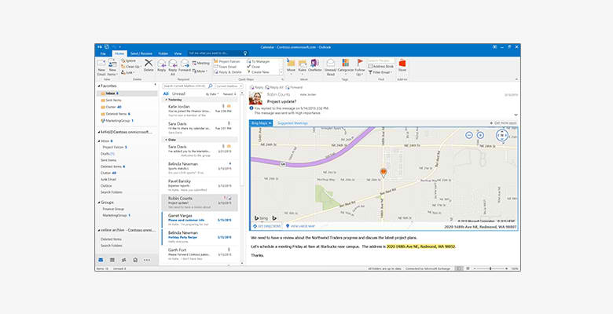

## **Outlook**

Easily manage your email, calendar, contacts, and tasks. Push email support keeps your inbox up to date, conversation view groups related messages, and calendars can be viewed side-by-side for planning.

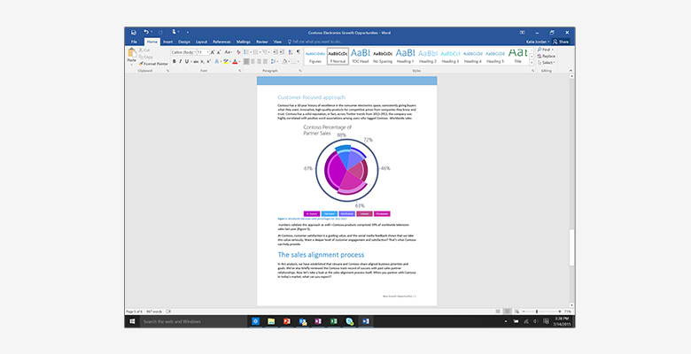

## **Word**

Create and share professional-looking documents with state-of-the-art editing, reviewing, and sharing tools. The new Design tab provides quick access to features, and Smart Lookup shows relevant contextual information from the web directly inside Word.

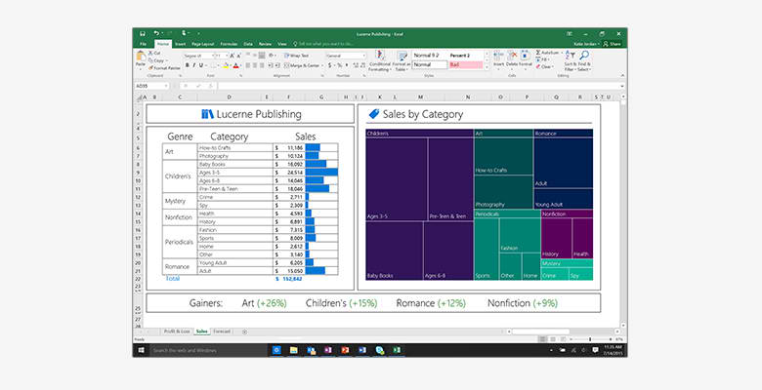

## **Excel**

Analyze and visualize your data in new and intuitive ways with a fresh user interface plus your favorite keyboard shortcuts. Leverage features like Analysis Toolpak, Slicers, and Formula Builder to save time, so you can focus on insights.

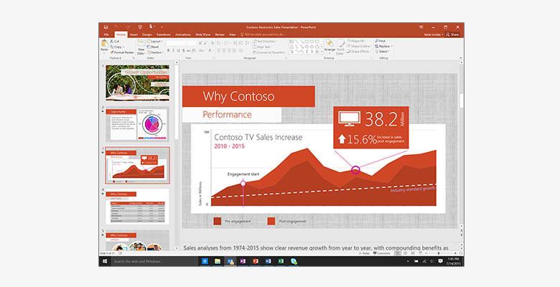

## **PowerPoint**

Create, collaborate, and effectively present your ideas with new slide transitions and an improved Animations task pane. Threaded comments alongside your slides help you incorporate feedback into your presentations.

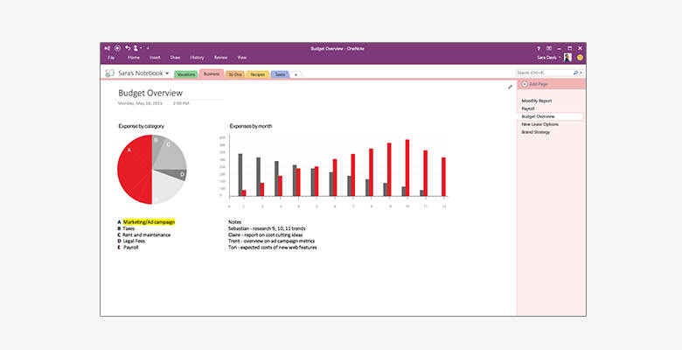

## **OneNote**

It’s your very own digital notebook, so you can keep notes, ideas, web pages, photos, even audio and video all in one place. Whether you’re at home, in the office, or on the move, you can take it all with you wherever you go while sharing and collaborating with others.

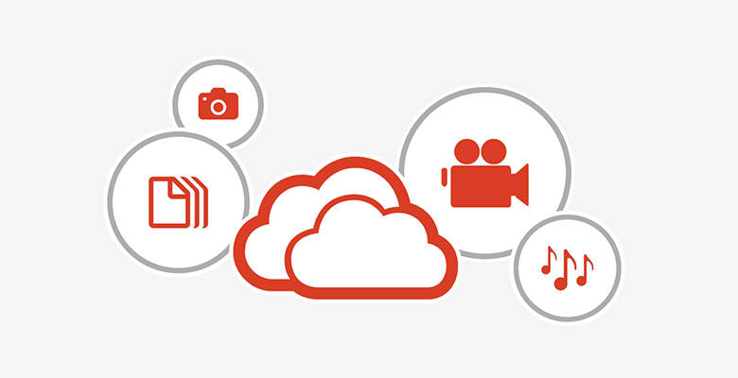

## **Your stuff anytime, anywhere**

Sign in to Office 2016 and use OneDrive to easily access your recent documents on any device with seamless integration.

# MS OFFICE HOME AND STUDENT 2016 MEDIALESS

Top of Form

* **For 1 PC**
* **Fully installed versions of Word, Excel, PowerPoint, and OneNote**
* **Store files in the cloud with OneDrive**

## **Word**

Create and share professional-looking documents with state-of-the-art editing, reviewing, and sharing tools. The new Design tab provides quick access to features, and Smart Lookups shows relevant contextual information from the web directly inside Word.

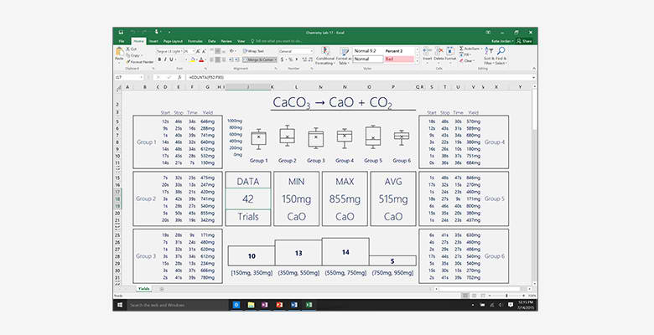

## **Excel**

Analyze and visualize your data in new and intuitive ways with a fresh user interface plus your favorite keyboard shortcuts. Leverage features like Analysis Toolpak, Slicers, and Formula Builder to save time, so you can focus on insights.

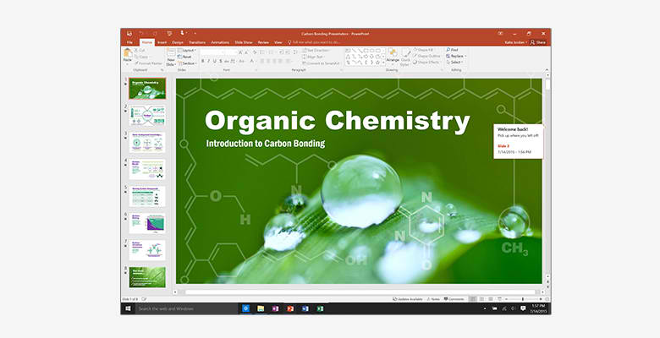

## **PowerPoint**

Create, collaborate, and effectively present your ideas with new slide transitions and an improved Animations task pane. Threaded comments alongside your slides help you incorporate feedback into your presentations.

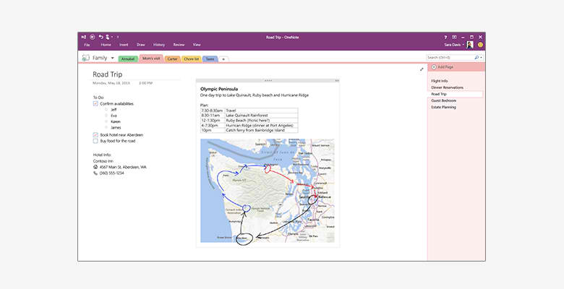

## **OneNote**

It’s your very own digital notebook, so you can keep notes, ideas, web pages, photos, even audio and video all in one place. Whether you’re at home, in the office, or on the move, you can take it all with you wherever you go while sharing and collaborating with others.



## **Your stuff anytime, anywhere**

Sign in to Office 2016 and use OneDrive to easily access your recent documents on any device with seamless integration.

Bottom of Form

Bottom of Form